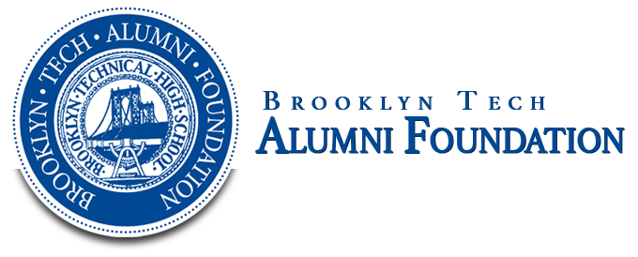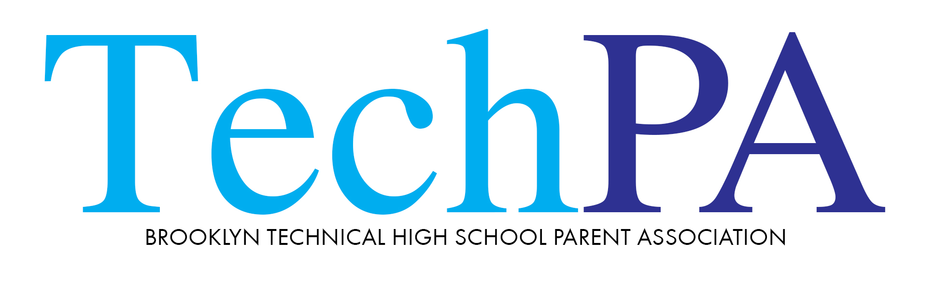

BTHS Benefit - May 11th, 2017
Benefit Auction Donation Form

Business/Donor Name (as it should appear in catalog)_________________________________________________________
Donor Contact Name (If different from above)_______________________________________________________________
Address______________________________________________________________________________________________
Phone_______________________________________________________________________________________________
Email (please write clearly! This is how we will send your receipt)________________________________________________
Name of Item (as it should appear in catalog)________________________________________________________________
Item Description/Restrictions_____________________________________________________________________________
_____________________________________________________________________________________________________
_____________________________________________________________________________________________________
Estimated Dollar Value___________________ Expiration Date_________________________________________________
How will your donation get to the school?
___ I will mail it to the school ____I will deliver it to the school ____I will email form and vouchers to BENEFIT@bths.edu
Donor Signature_________________________________________ Date______________________
Solicited By_______________________________________ Name of child and graduation year_______________________
Please return your donation form by April 7th, 2017.
Please mail or deliver donations to: A.P. Kelly Nottingham, Room 1W2, Brooklyn Tech Benefit, 29 Fort Greene Place, Brooklyn, New York 11217. Vouchers, gift certificates and tickets may be emailed along with your donation form to BENEFIT@bths.edu

